CYBERSECURITY SIWES TRAINING PROGRAMME
WEEK 6 PROJECT REPORT
Ethical Reconnaissance: OSINT and Basic Nmap

Student name: [DANIEL OPADOTUN]
Institution: [UNIVERSITY OF JOS]
Instructor: [MR. EXCEL]
Submission date: [23RD OCTOBER, 2026]

1. Introduction and Objectives
This project practices two foundational cybersecurity activities: Open-Source Intelligence (OSINT) and basic network mapping with Nmap. The work is intended to demonstrate an ethical and repeatable process: define the scope, collect evidence from permitted sources, validate observations, interpret results cautiously and report only what the evidence supports.
The objectives are to:
- Explain the difference between passive and active reconnaissance.
- Collect relevant information from permitted public sources and record where it came from.
- Distinguish direct observations from assumptions and security conclusions.
- Use basic Nmap commands safely against localhost or an instructor-approved lab target.
- Explain scan results without claiming more than the evidence demonstrates.
- Present evidence and practical recommendations in a concise technical report.

2. Scope, Authorization and Safety Boundaries
Complete the following scope record before performing practical work.
Safety statement: I will scan only a computer I own/control, an isolated lab, or a target explicitly assigned and approved by my instructor. If I discover that a target is outside the authorized scope, I will stop and inform the instructor. I will not include passwords, tokens, recovery codes, private keys or unnecessary personal information in evidence or the report.

3. Methodology: OSINT Sources and Nmap Commands Used

3.1 OSINT method

3.2 Nmap method
I ran these commands in the authorized Kali/Linux terminal. And saved the raw output unchanged.
nmap --version
nmap -h
nmap -oN nmap_localhost.txt 127.0.0.1
nmap -sT -p 22,80,443 [APPROVED_LAB_TARGET] [ 172.67.155.107]

4.Nmap Results
Nmap version | 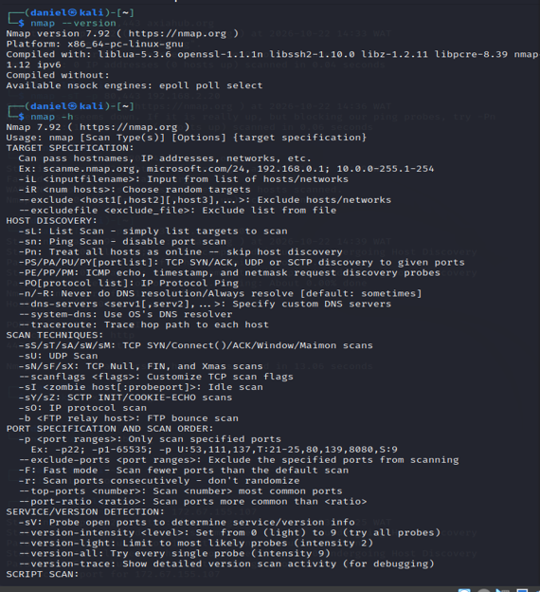
Help output evidence | 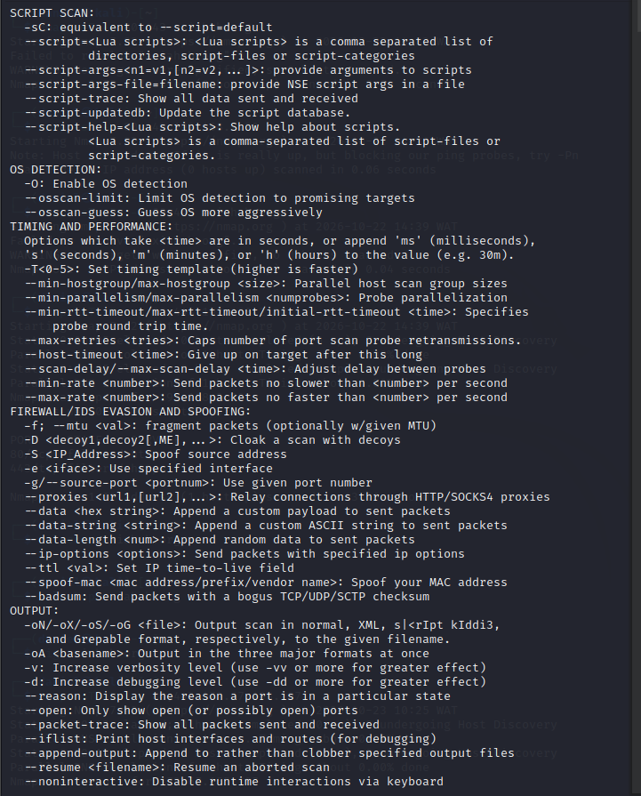
Exact target | 172.67.155.107
Exact command run | 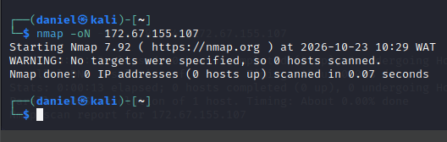
Date/time | 10:29 WAT. 2026-10-23
Raw output file
Evidence screenshot | [Insert filename, e.g. Evidence_01.png, after taking your own screenshot.]

5.1 Raw Nmap output
Actual scan output is transcribed below from the supplied terminal screenshot. Save and submit the raw nmap_localhost.txt file separately; the screenshot is not a substitute for the unchanged raw output file.
Actual output:
Nmap 7.92 ( https://nmap.org ) at 2026-10-22 13:26 WAT
Nmap scan report for localhost (127.0.0.1)
Host is up (0.00011s latency).
All 1000 scanned ports on localhost (127.0.0.1) are in ignored states.
Not shown: 1000 closed tcp ports (conn-refused)
Nmap done: 1 IP address (1 host up) scanned in 0.11 seconds

5.2 Result summary
The output reports the host as up and lists both selected ports as `filtered`.
Interpretation: Nmap did not receive enough information to decide whether those ports were open or closed. Filtering, firewall rules, or other network conditions may explain the result.
The result is a point-in-time observation. It is not evidence by itself that the target is vulnerable or that the web service is unavailable to all users.

5. Interpretation: What the Evidence Supports and Cannot Prove

Responding host versus non-responding host
A host reported as responding indicates that it replied to the scan's probes. A host that does not respond may be offline, unreachable, or affected by filtering or network configuration; non-response alone does not prove that the host is absent.

Open, closed and filtered ports
An open port indicates that an application is accepting connections on that port at the time of the scan. A closed port responds but no application is listening there. A filtered port means Nmap cannot determine the state confidently because packet filtering or another network obstacle interferes.

Detected service versus confirmed vulnerability
A service or open port is not, by itself, proof of a vulnerability. Confirming a vulnerability requires additional appropriate evidence and an authorized assessment. A scan reporting no open ports does not prove that the system is secure.
Interpretation of my own scan: The scan supports that, from the local machine at the time of testing, localhost responded and the 1,000 TCP ports checked were reported closed. The scan was limited to localhost and the default 1,000 TCP ports; it does not describe other devices, all possible ports, other protocols, or the system's overall security. Results can also be affected by local configuration and timing.

6. Reflection and Conclusion

6.1 Reflection draft (personalize before submission)
This exercise helped me understand that reconnaissance and vulnerability confirmation are different stages of a security assessment. OSINT collects information from permitted public sources, while Nmap actively probes an authorized target and reports network and port states. Neither activity by itself proves that a system can be compromised. I also learned that findings should be linked to evidence, and that confidence should reflect source quality and verification rather than assumption.
For the Nmap practical, I confirmed that Nmap 7.92 was installed and reviewed its help output. I then ran the localhost scan using `nmap -oN nmap_localhost.txt 127.0.0.1`. The screenshot shows localhost (127.0.0.1) was up and that all 1,000 scanned TCP ports were reported closed with connection refused. The limitation was that the scan covered localhost and the default 1,000 TCP ports only; it does not establish the security status of the whole computer or any other device.

Cybersecurity_SIWES_[Your_Name]/
└── Week_06/
├── 01_OSINT_Worksheet/
├── 02_Source_Evidence/
├── 03_Nmap_Commands/
├── 04_Scan_Output/
├── 05_Report/
└── 06_Reflection/

Evidence Screenshots Supplied
Appendix B1 — Nmap version output
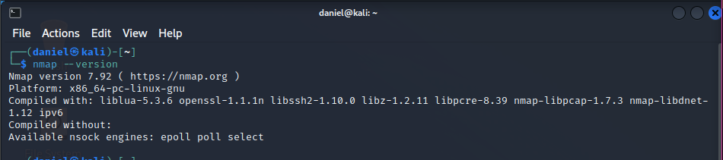

Appendix B2 — Nmap help output (nmap -h)
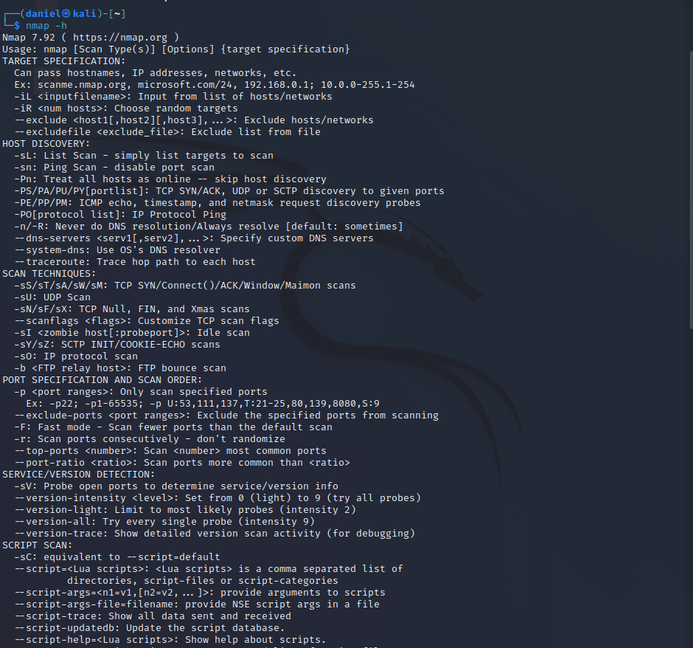

Appendix B3 — Nmap help output continuation
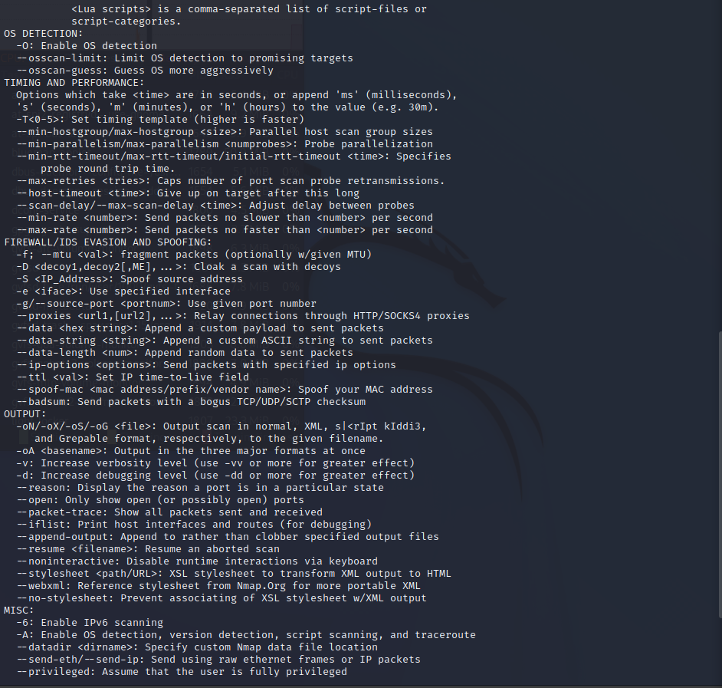

Appendix B4 — Nmap help output examples
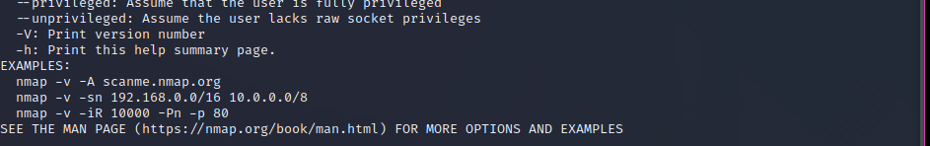

Appendix C1 — Localhost scan output
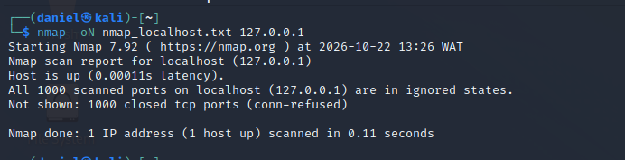

Revised Case Study: AxiaHub Public Website
Target organization: Axia Technology and Innovation Hub (Axia Hub). Primary public website reviewed: https://axiahub.org/. This revision replaces the fictional AxiaHub case pack as the main case study. The observations below are based on publicly accessible website/search-index information and should be rechecked in a browser on the date of submission.

Public-source OSINT observations
ID | Observation | Source | Confidence | Limitations
AX-01 | The official website presents Axia Hub as a technology and innovation hub and describes training, coworking, startup incubation, talent outsourcing, and community initiatives. | https://axiahub.org/ (homepage; accessed 22 Oct 2026) | High | Website claims are self-published and are not independently audited.
AX-02 | The About page describes partnerships with universities, impact on high schools, startup incubation, and job-placement activities. | https://axiahub.org/about-page/ (accessed 22 Oct 2026) | High | Counts and impact statements are published by the organisation and were not independently verified.
AX-03 | The website lists cybersecurity among its focus technology skills, alongside web development, data science, mobile development, and AI/robotics. | https://axiahub.org/ (homepage; accessed 22 Oct 2026) | High | This does not establish anything about the security posture of the website.
AX-04 | The contact page publishes a Jos, Plateau State, Nigeria address and business contact details. | https://axiahub.org/contact-page/ (accessed 22 Oct 2026) | High | Public contact details may change; avoid reproducing personal data not needed for the project.
AX-05 | Axia Hub's public LinkedIn company profile identifies its sector as Information Technology & Services and lists Jos, Plateau as its location. | https://ng.linkedin.com/company/axia-hub (accessed 22 Oct 2026) | Medium-high | Third-party profile content can be outdated and should be cross-checked against the official site.
Cross-check note: AX-01 and AX-02 are both official self-published sources, so they corroborate the organisation's own description but are not independent verification. AX-05 is a third-party source and offers a separate comparison point.

Nmap status — AxiaHub target scan still required
The current screenshots document a localhost practice scan, not an AxiaHub scan. The screenshot from 22 October 2026 at 14:08 WAT shows 22/tcp (SSH), 80/tcp (HTTP), and 443/tcp (HTTPS) closed on 127.0.0.1. Do not report these as AxiaHub findings.
After confirming the written scope/authorisation covers axiahub.org, run the following limited scan from the Kali terminal:
nmap -sT -p 80,443 axiahub.org
Save the terminal output and screenshot, record the date/time, and replace this placeholder with the actual result. Do not infer open/closed ports from a website loading in a browser. If the domain resolves to a third-party CDN/hosting provider, confirm that the authorised scope covers that infrastructure before scanning.

References
- Axia Hub official homepage. https://axiahub.org/
- Axia Hub About page. https://axiahub.org/about-page/
- Axia Hub Contact page. https://axiahub.org/contact-page/
- Axia Hub company profile on LinkedIn. https://ng.linkedin.com/company/axia-hub

Additional Nmap Evidence — Private Network Target
Screenshot evidence captured on 22 October 2026 at 14:39 WAT. Command used: nmap -sT -Pn -p 80,443 192.168.2.20.
Port | Service | Observed state
80/tcp | http | filtered
443/tcp | https | filtered
Nmap reported the host as up and both tested ports as filtered. A filtered state means Nmap could not determine whether the ports were open or closed because packet filtering or another network condition prevented a definitive response. This target is 192.168.2.20, a private-network address, so this screenshot is not evidence about AxiaHub's public website. The device owner and the scope of authorization for this private address must be confirmed before drawing further conclusions.
Evidence: Screenshot 8 — Nmap TCP scan of 192.168.2.20.
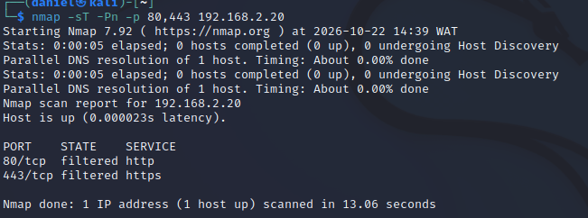

Report Revision Note
The fictional GreenBasket case material has been removed from this version. The case study is AxiaHub. Public-source OSINT observations are listed in the AxiaHub section. The Nmap screenshots currently available are localhost/private-network practice results only; they are not presented as scan results for AxiaHub.

Detailed Explanation of Terminal Screenshots
This section explains the terminal screenshots used as evidence in the Week 6 presentation. It distinguishes help-menu information, command syntax, and actual scan results. A help screen documents available options; it does not show that every listed option was executed.

Screenshot 1 — Nmap target specification and scan techniques
The screenshot displays part of Nmap's help output. It lists target and scan options. For example, -sL lists targets without scanning their ports, -sn performs host discovery without a port scan, -Pn skips host discovery, and -sT selects a TCP connect scan. This is reference evidence showing that the available options were reviewed, not evidence that all listed scans were executed.

Screenshot 2 — Scripts, OS detection, timing and output
This screenshot continues the Nmap help output and describes additional options. -sC runs Nmap's default scripts, -O attempts operating-system detection, -T controls timing, and -oN writes results in normal text format. These options should only be used when appropriate to the authorised scope. Their appearance in the help menu does not prove that script scanning or OS detection was performed.

Screenshot 3 — Scan of the instructor-provided target
The terminal command is `nmap -sT -Pn -p 80,443 172.67.155.107`. The -sT option requests a TCP connect scan; -Pn skips host discovery; and -p 80,443 restricts the scan to TCP ports 80 and 443. The output reports the host as up and lists 80/tcp as filtered (http) and 443/tcp as filtered (https). A filtered result means Nmap could not determine whether the port was open or closed because filtering or other network conditions prevented a conclusive response. The screenshot does not prove that either port is open, that a service is vulnerable, or that the target's overall security posture has been assessed.

Screenshot 4 — Output-file command syntax error
The command `nmap -oN 172.67.155.107` produces a message that no targets were specified. The -oN option requires a filename argument. In the shown command, the IP address is consumed as the output filename, leaving no target for Nmap to scan. For a limited scan within the instructor's authorised scope, the corrected syntax is `nmap -sT -Pn -p 80,443 -oN axiahub_scan.txt 172.67.155.107`. Here, axiahub_scan.txt is the output filename and the final argument is the target IP address.

Screenshot 5 — Nmap version and help menu
The screenshot reports Nmap version 7.92 and shows the command usage/help output. This verifies the version displayed by the local Kali environment at the time of capture and demonstrates that the help menu was consulted. It is not, by itself, a target scan result.

Practice scans and target attribution
Other practice evidence in the project includes a scan of 127.0.0.1 and a scan of 192.168.2.20. The address 127.0.0.1 is localhost and refers to the local machine. The address 192.168.2.20 is a private-network address. These results must be labelled as local/private-network practice and must not be presented as results for AxiaHub. The scan of 172.67.155.107 is treated as the target exercise because the student reports that the instructor supplied that IP for AxiaHub.

Evidence limitations and responsible interpretation
The screenshots support a limited set of conclusions: Nmap 7.92 was available; the help menu was reviewed; an output-file command was entered incorrectly; and a scan of the instructor-provided IP reported ports 80 and 443 as filtered. They do not demonstrate exploitation, identify a confirmed vulnerability, or provide a comprehensive security assessment. Results reflect the network conditions at the time of the scan. Any repeat scan must remain within the explicit scope authorised by the instructor or system owner.

Suggested oral explanation
These screenshots show my Nmap setup, the help options I consulted, the scan command I used, and the output I received. I scanned the instructor-provided target IP on TCP ports 80 and 443. Both ports were reported as filtered, meaning Nmap could not determine whether they were open or closed. I also learned that the -oN option needs an output filename, so I corrected the command syntax. I have kept localhost and private-network practice results separate from the target evidence and have not claimed that the filtered result proves a vulnerability.

